**Using GIS analysis tools to Investigate the pattern of traffic accident distribution in Montgomery County, Maryland State, US**

**Student Name Zhaokai Guan**

**Student ID 130988215**

**Story Map Link: https://storymaps.arcgis.com/stories/b8f33e993cf2427a9867557fb0019114**

**Introduction:**

I am currently running a machine learning project with another data scientist, and one of the study questions is about traffic accidents and its contributing factors in Montgomery country in Maryland State, US.

During the data cleaning stage, we found out the data from US open data marked every single accident’s latitude and longitude. Luckily, I am taking this GIS course, and I decided to conduct an extension study of the main research by using the coordination and other GIS information from US open database to analysis the traffic accidents geographical distribution patterns.

**Data collection:**

The raw data is from data.gov which is the only official public data sharing website running by the US government. The link to the leading page of the raw data is from this link below.

https://catalog.data.gov/dataset/crash-reporting-drivers-data

The raw data is in CSV format, and it contains 159,357 rows, and 41 columns.

**Data preprocessing:**

After data cleaning stage, there were only around 100,379 rows, and 12 columns left due to the missing values and other machine learning reasons. And this is where this extension study forked with the main study branch. I further reduced the columns into 3 and exported the data into the csv format.

You can find my source code and GIS project back from this link below.

https://github.com/zkrguan/CIND820_capstone

**Data importing and initial analysis:**

Acquired the map coordination data, I figured out an approach to import the csv data by using arc GIS’s “add data” -> “x,y point”. It is worth to note that the arc GIS is very smart because it automatically found out the column contains latitude and latitude from the csv file. After importing, each traffic accident was marked on the map represented by a dot. Here is a raw result from the “x,y point”.

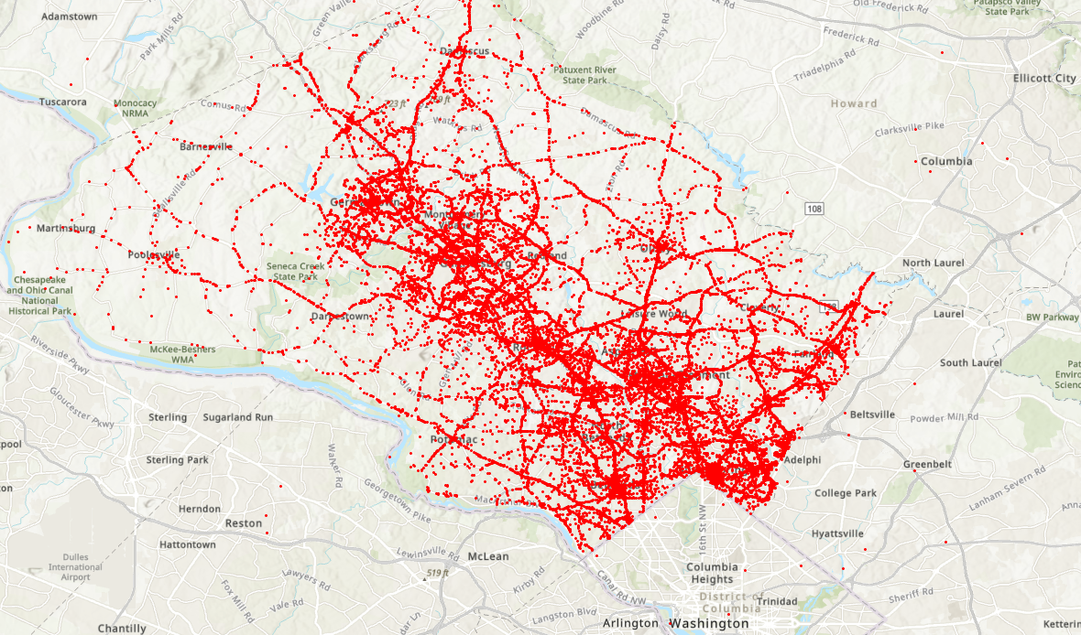

This is not meaningful and well-presented, but the distribution pattern somewhat exists. For example, there are more accidents on the southeast, east and south part of this map.

**Pattern recognition**

It is noticeable that some accident’s coordination fallen into the Washington DC. Before going further, I used the clip analysis feature to get rid of the dots not in the Montgomery County. Now, the question is where to find the Montgomery County’s Boundary?

Luckily, I found this public database hosted by Montgomery County Government.

https://montgomeryplanning.org/tools/gis-and-mapping/data-downloads/

This open database does have tons of GIS data ready for the researchers to download for free. Also, I started thinking about using heat map to make those more than 100,000 dots into something presentable format. And the result is like this,

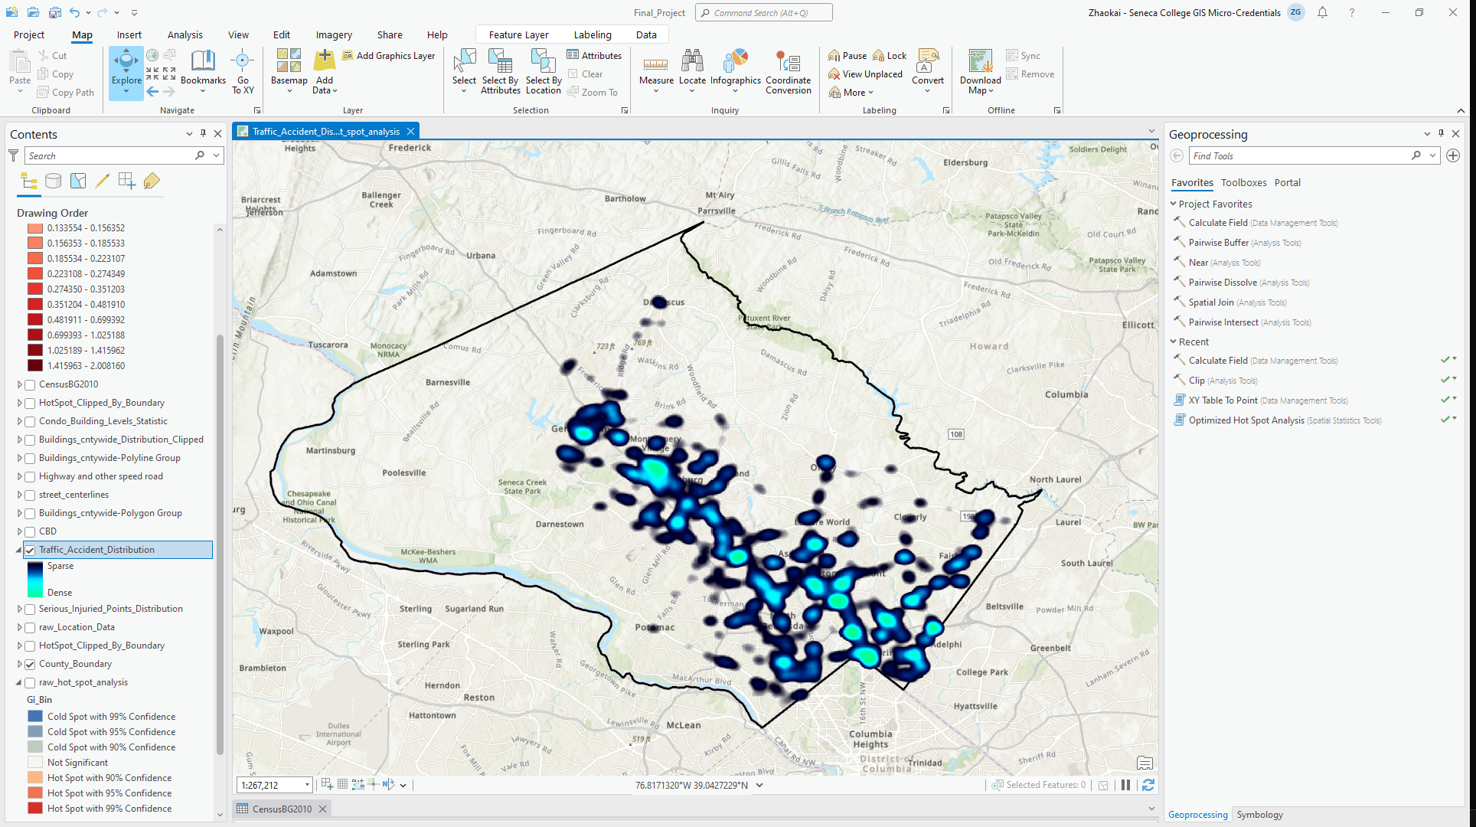

To further investigate this pattern, I used the “hot spot and cold spot tool” in arc GIS and further. By the way, I used professor recommended natural breaks. It is indeed better than other methods in this dataset.

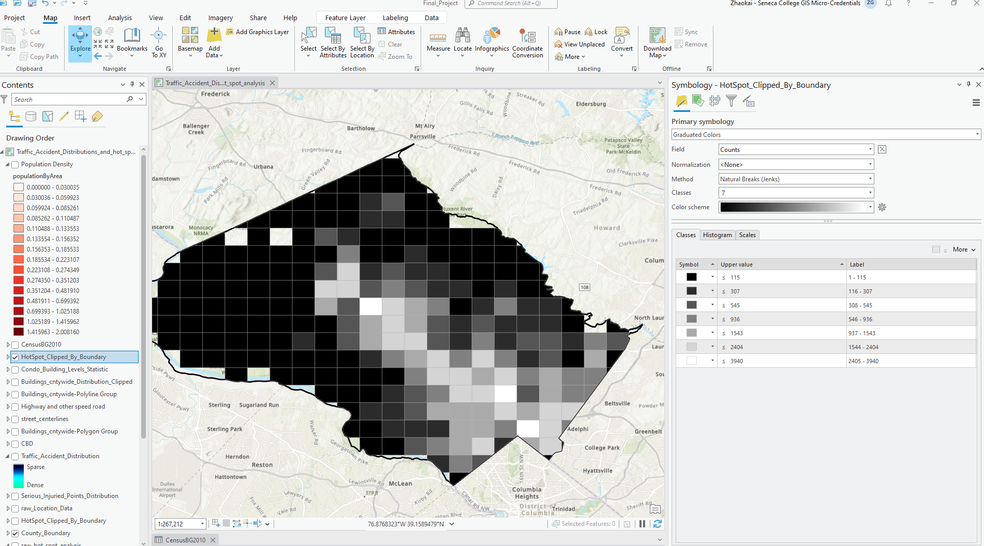

Now we can see, the traffic accidents distribution seems following a major highway. And as you probably noticed, the closer it gets to the Washington DC, there are more accidents happens.

**Pattern analysis:**

Is it distribution related to the road? When the density of the roads getting rises, the density of traffic accidents will rise too? Also, the traffic accident’s hot spots are aligned with the major traffic intersections. To prove my guess, I downloaded the road GIS assets from the open data base, and only keep the 10 types of major roads type. And then, by putting the heat map layer and the major roads layer together. I found the result is like this.

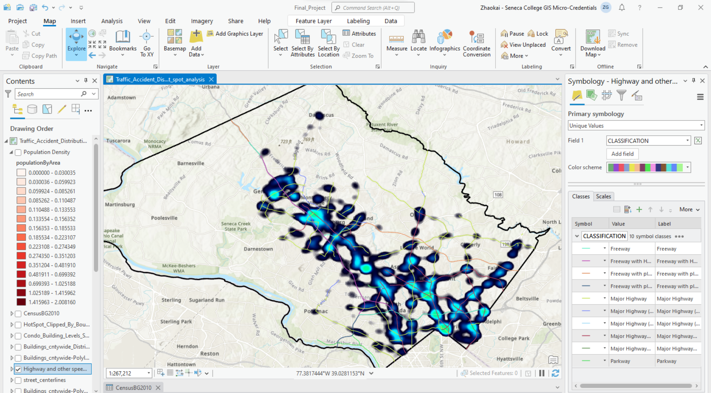

And the result layer can prove my assumption above. Indeed, when there are multiple major roads intersecting with each other major roads, traffic accidents hots spots are likely to exists around that area.

More major roads meaning this area’s traffic volume is high and can have an assumption that the density of the traffic accidents is positively correlated with the local population density.

To get the population data from the Montgomery County, I downloaded from the Montgomery Open Data base. And I found out the Census GIS data from 2010. After imported the data, I found out the attribute table does not contain the data I wanted (population density). Luckily, GIS 502 professor showed us in class how to make a new column and calculate the field by other two fields.

The formula for the new column is population *1000 / SHAPE_area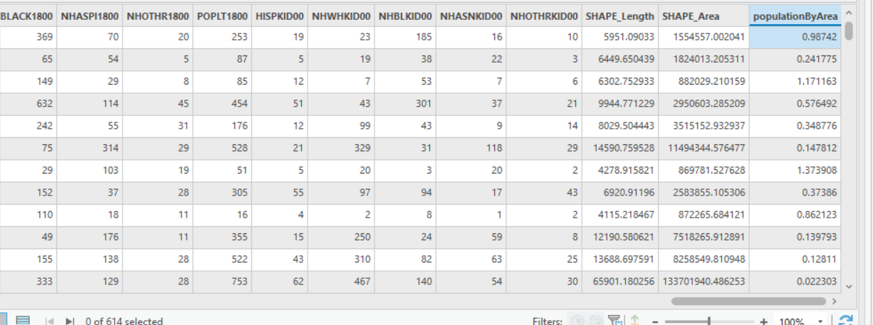

Use the new column, we roughly calculate the population density. Use the density to adjust the symbology of this layer. Here is a result layer.

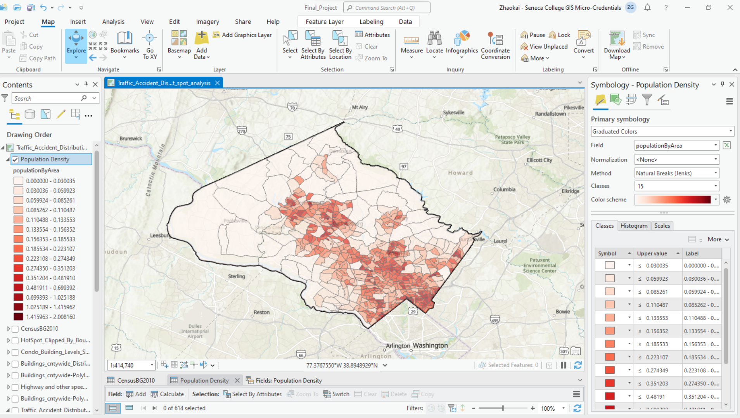

To prove we did it properly, I found an image made by the local government’s GIS team.

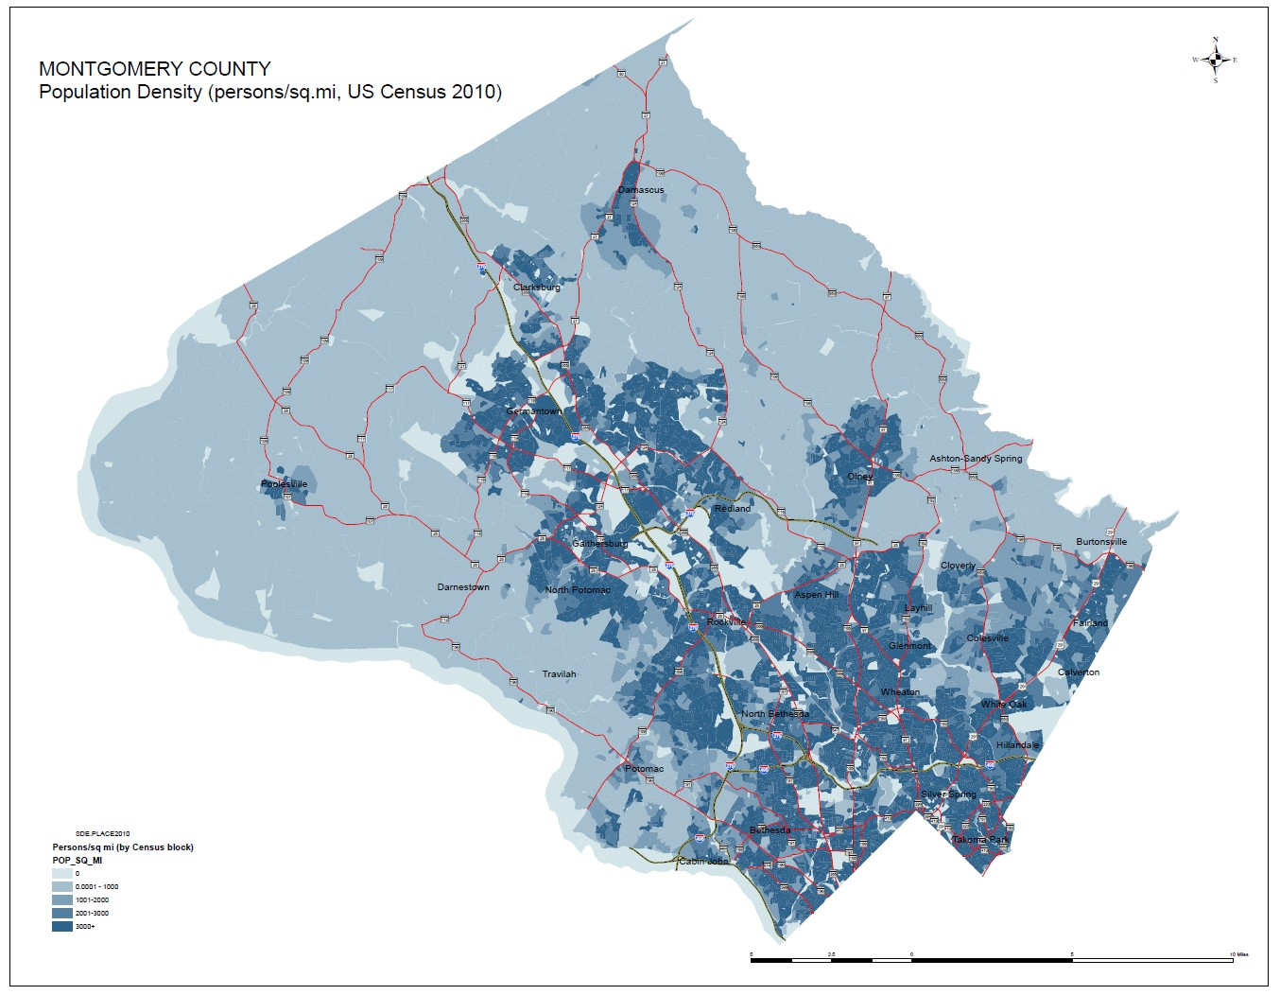

Most areas are matching with the professional team’s result, so that means we did the population density distribution accurately. To display the heat map and population density distribution together, I changed the color of the heat map and adjusted the top layer’s transparency slightly. And the result looks like the following map.

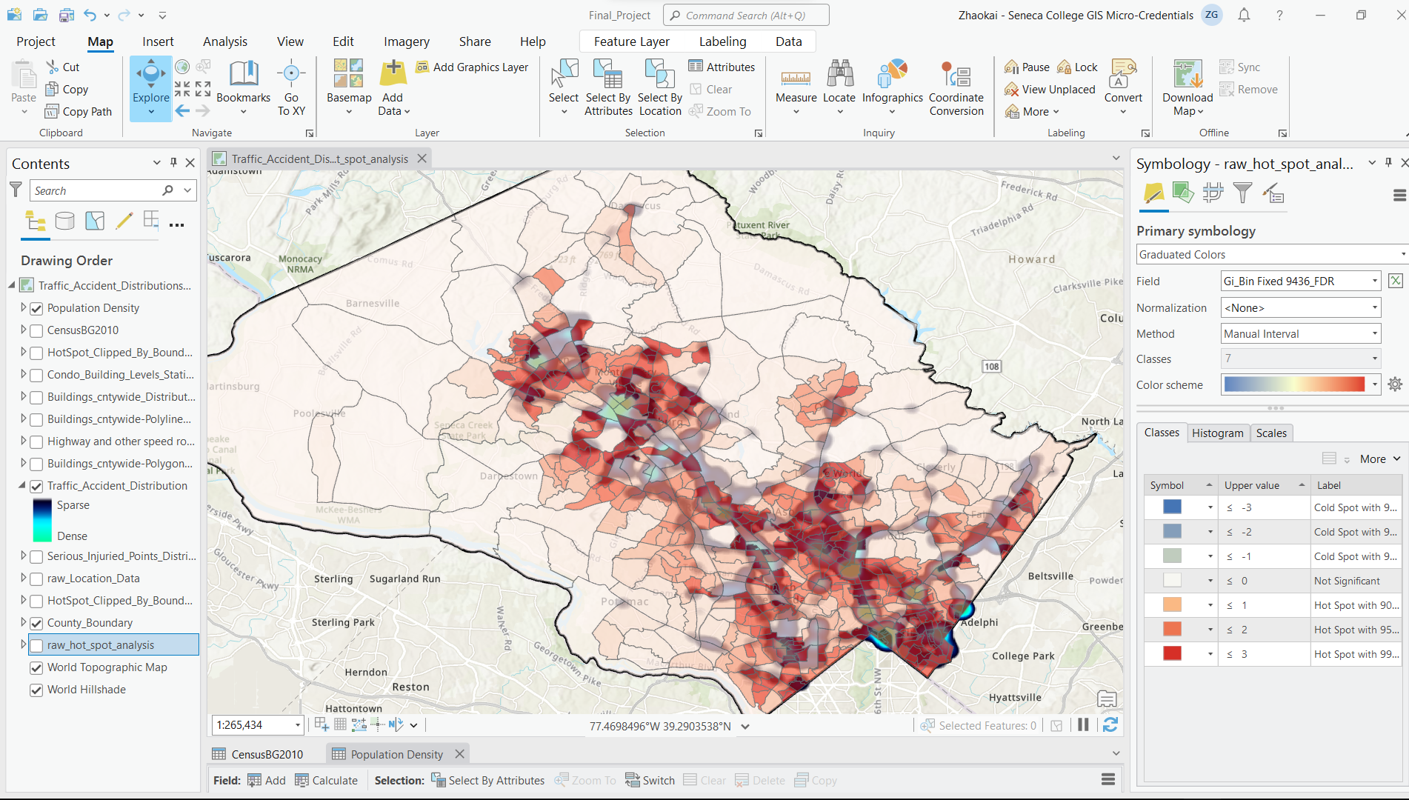

And this should be enough to prove that the positive correlation between the population density and the density of traffic accident. It does make sense, more people living in an area, the chances of having traffic accidents could be higher. However, this conclusion is still aligning with our common sense. What would be the valuable outcomes of this?

**Valuable outcomes:**

For the machine learning project, I am involved, it is worth to notice that not all the traffic accident hotspots aligning with the population dense areas. Like the southwest corner of the map, there is a massive hot spot between two districts. So, this will be the data scientists’ task to figure out why that hot spot exists. In the future, we will update the research progress on the main branch of this machine learning project if these hot spots are not from the wrong data entry. By combining the power from GIS and machine learning model, the local authority could potentially make further actions according to the patterns and findings from the project. Eventually, there might be more people saved because of reduced traffic accidents. If you think about it, GIS not only can be used to improve people’s life quality, but also be used to save lives. This is definitely part of something amazing.

**Story Map Link:** <https://storymaps.arcgis.com/stories/b8f33e993cf2427a9867557fb0019114>

**Source:**

Data source: <https://catalog.data.gov/dataset/crash-reporting-drivers-data>

GIS open data: <https://montgomeryplanning.org/tools/gis-and-mapping/data-downloads/>

Github link to this forked project: <https://github.com/zkrguan/CIND820_capstone>

Github link to this main project:<https://github.com/catherine12jiang/CIND820_capstone>

**Thank you, prof! Now GIS became to one of my hobbies during the spare time.**